CME Reports

The CME was conducted in HAMCH on 21 st August 2023. The CME was conducted in HAMCH on 21 st August between 2PM to 5PM at Dhanvantri Hall. He was an excellent speaker giving a talk on “Principles of healthcare management laid down by Acharya Charaka.”

The CME was conducted in HAMCH on 12 th February between 2PM to 5PM at Dhanvantari Hall. The guest of the day was Dr.Shruthi. B. V, Assistant Professor , Department of Prasooti tantra and Stree roga. She delivered the lecture on most important topic of current scenario on “Sexual And Reproductive Health and Rights” .

The CME was conducted on February 28th, 2024. The guest of the day was Dr. Rajesh Hiremath, Consultant and HOD , Department of Criticalcare Medicine,Aveksha Hospital, Bengaluru.The aim of this CME was to provide an opportunity to upskill the existing knowledge in the field of critical care medicine.

The CME was conducted in HAMCH on 7th May, 2024. The guest of the day was Dr.Deeksha D Shetty, Assisstant Professor , Department of Roga nidana Avum Vikruti Vijnana. She delivered the lecture on Clinical Evaluation of Pranavaha sroto Dusti lakshana.

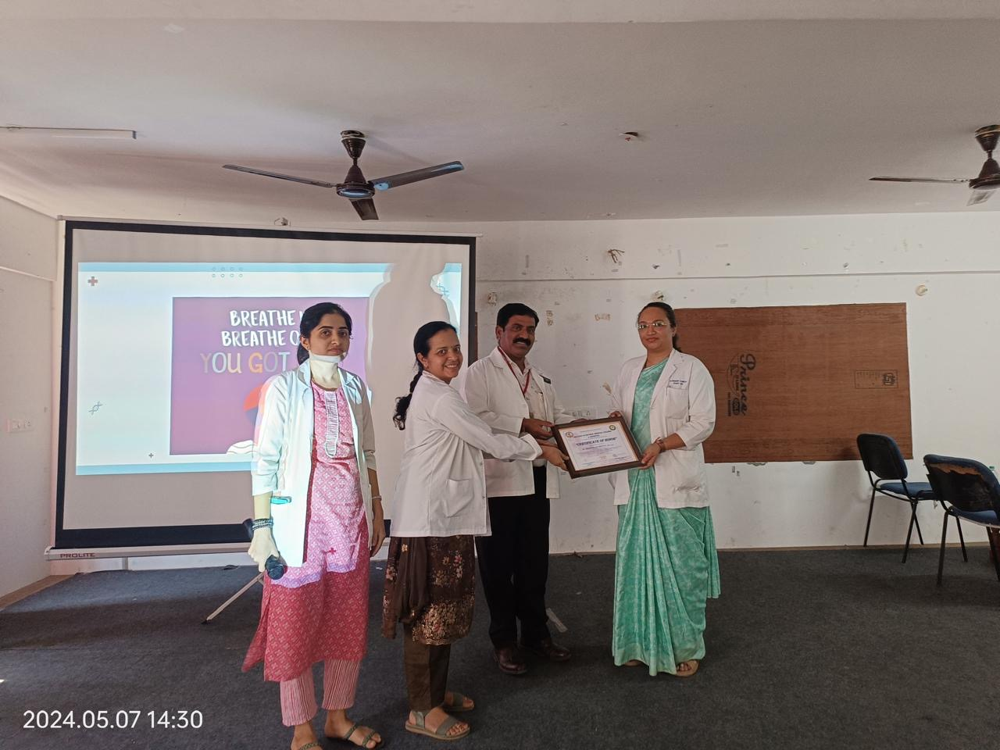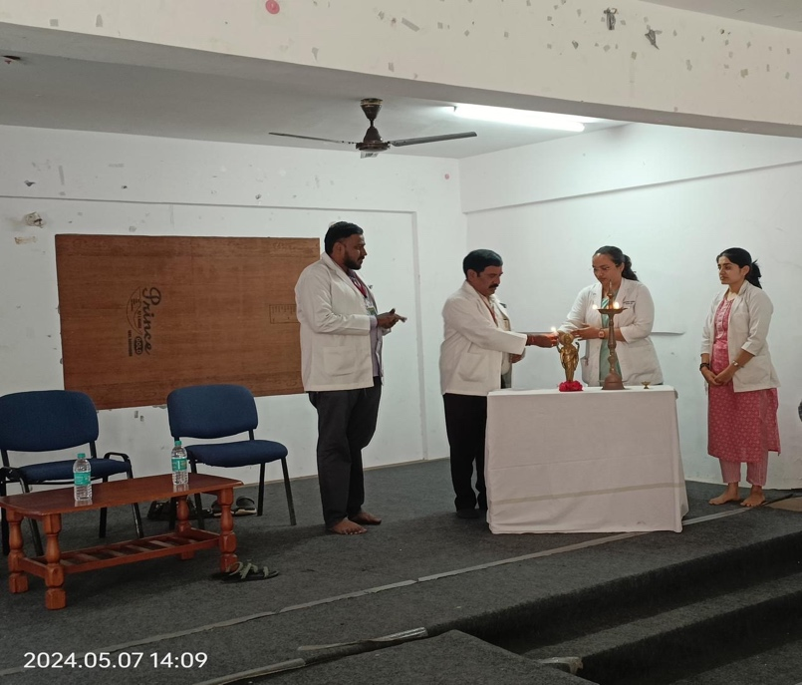

The CME was conducted in HAMCH on 23rd May, 2024. The guest of the day was Dr.Vasundara S, Professor , Department of Kayachikitsa. She delivered the lecture on most important topic of current scenario on “Clinical Management of Urolithiasis Mootrashmari.”

