College : Hill Side Ayurveda Medical College, Bangalore

Permission Details
Description |  | Ref No. & Date and Intake
Government of India |  | R12011/26/2013EP( IM1), Dated. 17/10/2014
Apex Body |  | No. R12011/26/2013EP( IM1) for (201617)
Government of Karnataka |  | HFW184PTD2004, DATED 28/02/2004
RGUHS |  | ACA/AFF/AY56/ 2019-20,
Govt Matrix |  | HFW184PTD2004, DATED 28/02/2004
Fee Amount : | DD No. : |  | DD Date : | Bank Name : KARNATAKA | Date of Submission : 30/02/2021

Seat Matrix Details
Course | Sanctioned |  |  |  | Admitted |  |  |  | Remarks
 | TS | GS | MS | NRI/Foreigner | TA | GS | MS | NRI/Foreigner
1. BAMS | 50 | 10 | 40 | 00 | 50 | 0 | 50 | 0

Student Admission Details for BAMS Course
SN | Student Name  &  Remarks | Photo | Blood Group | Father Name  Student Permanent Address &  Phone No. | Sex | Caste | Nationality | Seat  Category | CET Rank Comedk  Rank KRLM  Rank | Qual Exam | Optional Subjects | Register No | Passed Year | University/ Board | Max. Marks | Secured Marks | Date of Birth | Date of  Admission
1. | ADITYA NITIN VARADE | 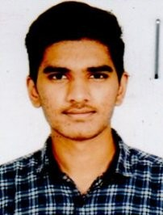 | B pos | NITIN  Flat NO. 6, ANNUNNAY,  APPARTMENT, NERA WATER TANK, OPP IDBI (AT),  MAHATMA NAGAR, NASHIK -  422007, Mahatastra  - | Male | GM | Indian 21 | Management Seats | 686378,  495089%  0, 0%  0, 0% | PUC | PCB | S0010180102 | 28/02/2019 | HIGHER SECONDARY EDUCATION , PUNE | 300 | 151 | 07/05/2002 | 16/02/2021
2. | ANANYA YUVARAJ KUMAR | 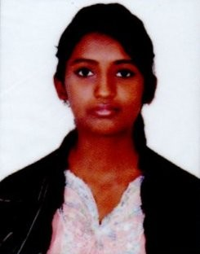 | A neg | M YUVARAJ KUMAR  No. 80/A, 21st C Main,  MARENAHALLI , JP NAGARA 2ND PHASE, BANGALORE 560  078  - | Female | GM | Indian 17  Urban | Management Seats | 579423,  47053%  0, 0%  0, 0% | puc | PCB | 216303 | 14/07/2020 | department of  pre university  education | 300 | 200 | 20/02/2002 | 16/02/2021
3. | ANKITHA.S | 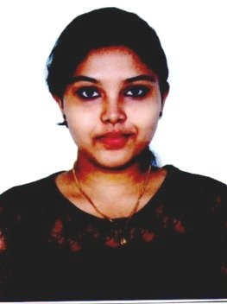 | A neg | SOMALINGAIAH.B.C No. 163, 1ST CROSS, SAPTHAGIRI NAGAR,  HOSKEREHALLI, BANGALORE - 85, KARNATAKA  - | Female | GM | Indian 17  Urban | Management Seats | 745066,  45419%  0, 0%  0, 0% | PUC | PCB | 971422 | 09/10/2020 | DEPARTMENT OF PRE  UNIVERSITY EDUCATION | 300 | 183 | 02/01/2003 | 16/02/2021
4. | ANSARI GUFRAN AHMED NASEER AHMED | 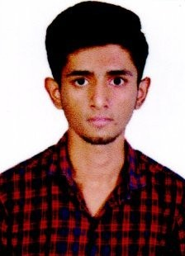 | A neg | NASEER AHMED  KHALIMAINSION "B" WING,  OPP RAVSAKABRASTANNTAR, GHASSWALAMUMBRATHANNE, MAHARASTRA  - | Male | GM | Indian 20 | Management Seats | 741476,  45419%  0, 0%  0, 0% | PUC | PCB | M0066471071 | 28/02/2020 | MAHARASTRA STATE BOARD OF HIGHER SECONDARY EDUCA | 300 | 234 | 11/09/2002 | 16/02/2021

5. | BHOSALE KULDEEP | 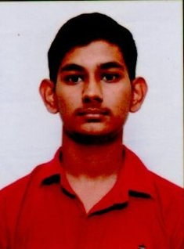 | A pos | B. BHARATH  H.NO. 3-5-61, HANUMAN  MANDIR ROAD, ZAHEERA BAD,  - | Male |  | GM | Indian 2 | Management Seats | 390190,  7137200%  0, 0%  0, 0% | puc | PCB | 1959227629 | 18/04/2019 | TELANGANA STATE BOARD OF INTERMEDIATE EDUCATION | 300 | 165 | 06/04/2000 | 16/02/2021
6. | DIVEKAR  ANKITA DILIP |  | B pos | DILIP DIVEKAR  KADETHANNADI KADETHAN ,  PUNE , MAHARASRA - 412215 | Female |  | GM | Indian 21 | Management Seats | 449263,  6704840%  0, 0%  0, 0% | PUC | PCB | P046743 | 28/02/2018 | MAHARASTRA STATE BOARD  OF SECONDARY  EDUCATION, P | 300 | 205 | 10/06/2000 | 16/02/2021
7. | FAHEEM M WAHID |  | A neg |  |  | Male | GM | Indian 4 | Management Seats |  | puc | PCB | 065320074 | 31/05/2018 |  | 300 | 221 | 01/05/2000 | 16/02/2021
 |  | 
 |  |  |  | ABU NASAR WAHID  DHANIA BHETI, GAON,  NAGAON, ASSAM - 782122, ASSAM  - |  |  |  |  |  | 384635,  717753%  0, 0%  0, 0% |  |  |  |  | assam higher secondary  education council
8. | GAWALI DIVYA SHANKAR | 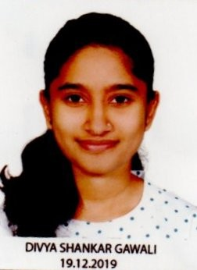 | B pos | SHANKAR  Plot No. B-54, Nashik, Opp TIP TOP Cement , Nice Satpur ,  Maharastra  - |  | Female | GM | Indian 20 | Management Seats | 0, 525775%  0, 0%  0, 0% | PUC | PCB | S001517 | 28/02/2020 | MAHARASTRA HIGHER SECONDARY EDUCATION, PUNE | 300 | 201 | 08/05/2002 | 16/02/2021
9. | GUPTA SONU ANIL | 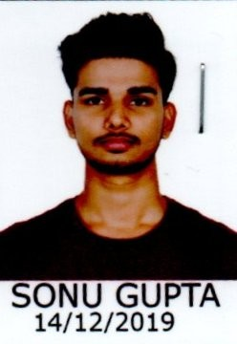 | B pos | ANIL GUPTA  4/40 B, VANRAI COLONY OPP THE HUB MALL GEORGEGAON, MUMBAI - 400065,  MAHARASTRA  - |  | Male | GM | Indian 20 | Management Seats | 348032,  7440420%  0, 0%  0, 0% | PUC | PCB | M074441 | 28/02/2017 | HIGHER SECONDARY EDUCATION PUNE | 300 | 159 | 26/09/1998 | 16/02/2021
10. | MAGAR SAYALI PRAKASH | 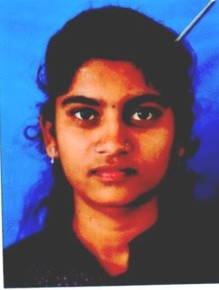 | B pos | PRAKASH  AT AWASARI POST VADAPUR ITEL, INDAPURA DIST PUNE MAHARASTRA  - |  | Female | GM | Indian 21 | Management Seats | 809160,  40701100%  0, 0%  0, 0% | PUC | PCB | P0864130457 | 28/02/2020 | HIGHER SECONDARY EDUCATION PUNE, | 300 | 159 | 02/08/2002 | 16/02/2021
11. | MAHESH | 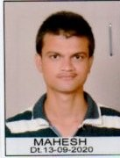 | A neg | RAMESH CHOPADE  -  - |  | Male | GM | Indian 17  Urban | Management Seats | 703235,  48552500%  0, 0%  0, 0% | PUC | PCB | 850343 | 09/10/2020 | DEPARTMENT OF PRE  UNIVERSITY EDUCATION | 300 | 158 | 01/06/2000 | 16/02/2021
12. | MANDAL JYOSHNA | 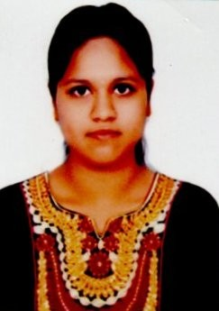 | A neg | M. SANJEEV KUMAR  KOTHA PETA, DHONE,  KURNOOL, ANDHRA PRADESH  - 518222  - |  | Female | GM | Indian 2 | Management Seats | 403253,  7035930%  0, 0%  0, 0% | PUC | PCB | 181021260 | 12/04/2018 | BOARD OF INTERMEDIATE EDUCATION,  ANDHRA PRADESH | 400 | 334 | 16/04/2000 | 16/02/2021
13. | MHATRE DIYA YASHAVANT | 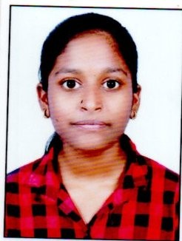 | A pos | YASHAVANT  AT WASHI, POS WASHI, TAL PEN DIST RAIGAD MAHARASTRA  - |  | Female | GM | Indian 21 | Management Seats | 675472,  55397800%  0, 0%  0, 0% | PUC | PCB | M048383 | 28/02/2020 | MAHARASSTRA STATE BOAD OF HIGHER SECONDARY EDUCA | 300 | 225 | 25/05/2003 | 16/02/2021

14. | NIKITA TOPPO | 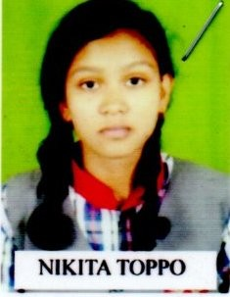 | A pos | PREM SMEL TOPPO  AMAKHERWA  MANENDRAGARH, WARD. No. 15, KOREA, CHATTISGARH  - | Female | GM | Indian 6 | Management Seats | 617076,  448150%  0, 0%  0, 0% | PUC | PCB | 12661563 | 13/07/2020 | CENTRAL BOARD OF  SECONDARY EDUCATION | 300 | 226 | 09/08/2001 | 16/02/2021
15. | NOORAIN TAJ | 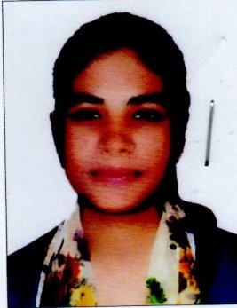 | A pos | IMTIYAZ KHAN  -  - | Female | GM | Indian 17  Urban | Management Seats | 705584,  48219400%  0, 0%  0, 0% | PUC | PCB | 346184 | 16/04/2019 | DEPARTMENT OF PRE  UNIVERSITY EDUCATION | 300 | 170 | 26/06/2001 | 16/02/2021
16. | PATIL ADITYA MOHAN | 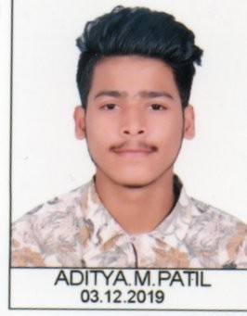 | A neg | MOHAN PANDURANG PATIL KL-5, SEC-2E, BIdNo-24, ROOM No. 13, KALAMBOLI,  NAVIMUMBAI - 410218,  - | Male | GM | Indian 21 | Management Seats | 753598,  4461900%  0, 0%  0, 0% | PUC | PCB | M0408732561 | 28/02/2019 | MAHARASGTRA STATE BOARD  OF SECONDARY AND HIGHER | 300 | 151 | 26/01/2001 | 16/02/2021
17. | POOJALINI NAYAK | 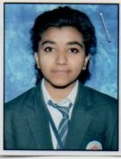 | A pos | NARENDRA NAYAK  visveshvarayapura,nelamangala Bangalore  - | Female | GM | Indian 17  Urban | Management Seats | 615919,  548106000%  0, 0%  0, 0% | puc | PCB | 535431 | 14/07/2020 | department of pre university  education | 300 | 252 | 13/02/2002 | 16/02/2021
18. | ROHIT KEMPRAI |  | A pos | BHAKAT SINGH KEMPRAI 87/37, PADASALAI STREET, KOZHAVUR VILLAGE,, PULIVANDAL POST, POLUR  TALUK, THIRUVANNAMALAI DISTRICT, TAMIL NADU -  - | Male | GM | Indian 4 | Management Seats | 750880,  4488310%  0, 0%  0, 0% | PUC | PCB | 3629914 | 26/05/2018 | CENTRAL BOARD OF  SECONDARY EDUCATION | 300 | 208 | 16/08/1999 | 16/02/2021
19. | SUMEET KEVAL JADHAV |  | A pos | KEVAL GHEWAR JADHAV SATMANE, RAVALGAON, TAL MALE GAON, DIST NASHIK, MAHARASTRA  - | Male | GM | Indian 20 | Management Seats | 766004,  439167%  0, 0%  0, 0% | PUC | PCB | S0168430240 | 28/02/2020 | MAHARASTRA HIGHER SECONDARY EDUCATION , PUNE | 300 | 233 | 08/04/2002 | 16/02/2021
20. | SYED RASOOL |  | A pos | SYED ABDUL RAHAMAN  SNR ASHIYANA HKGN NAGAR, ARSIKERE - 573103,  KARNATAKA  - | Male | GM | Indian 17  Urban | Management Seats | 693799,  490338000%  0, 0%  0, 0% | PUV | PCB | 435694 | 16/04/2019 | DEPARTMENT OF PRE  UNIVERSITY EDUCATION | 300 | 196 | 20/11/2000 | 12/06/2021

21. | KISHORRE MANDAL | 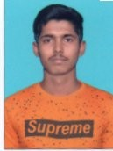 | A neg | PANCHANANA MANDAL  -  - | Male | GM | Indian 17  Urban | Management Seats | 621680,  543251000%  0, 0%  0, 0% | PUC | PCB | 289739 | 16/04/2019 | DEPARTMENT OF PRE  UNIVERSITY EDUCATION | 300 | 201 | 14/06/2001 | 16/02/2021
22. | UMME AIMAN MAKANDAR |  | A pos | SHALALSHAH  -  - | Female | GM | Indian 17  Urban | Management Seats | 767827,  436330000%  0, 0%  0, 0% | PUC | PCB | 807399 | 16/04/2019 | DEPARTMENT OF PRE  UNIVERSITY EDUCATION | 300 | 227 | 15/08/2001 | 16/02/2021
23. | GAWADE  VIDYACHARAN RAMCHANDRA |  | A pos | RAMACHANDRA  -  - | Male | GM | Indian 20 | Management Seats | 383548,  709228000%  0, 0%  0, 0% | PUC | PCB | P0191570055 | 28/02/2020 | MAHARASTRA STATE BOARD OF SECONDARY AND HIGHER S | 300 | 252 | 06/06/2002 | 16/02/2021
24. | TD VARSHA |  | A neg | T DEVENDRA BABU  -  - | Female | GM | Indian 17  Urban | Management Seats | 796199,  41483400%  0, 0%  0, 0% | PUC | PCB | 4635482 | 02/05/2019 | CENTRAL BOARD OF  SECONDARY EDUCATION | 300 | 237 | 07/10/2001 | 16/02/2021
25. | SHAIKH MO JAUWAD MO BABLU |  | A pos | SHAIKH GULBABLU TAHIR  MAHATMA GULE NAGAR, KADARI CHISHTI MANJIL  SECTION 17, NEAR HANUMAN MANDIR, ULHASANAGAR,  UTHASNAGAR,THAE, MAHARASTRA 7218217624 | Male | GM | Indian 20 | Management Seats | 474814,  651104000%  0, 0%  0, 0% | PUC | PCB | 8194894381 | 25/06/2019 | BIHAR SANSKRIT SHIKSHA  BOARD PATNA | 300 | 248 | 31/07/2002 | 16/02/2021
26. | LAKSHMISH. S |  | A pos | SATISH. G  gf. 05, BACHAPPA  APARTMENTS, GANESHA TEMPLE ROAD, KANAKAPURA MAIN ROAD,  DODDAKALLASANDRA,  BANGALORE, KARNATAKA  - | Male | GM | Indian 17  Urban | Management Seats | 906915,  334051000%  0, 0%  0, 0% | PUC | PCB | 438784 | 14/07/2020 | DEPARTMENT OF PRE  UNVIERSITY EDUCATION | 300 | 162 | 19/02/2002 | 16/02/2021
27. | VAVILALA  MANIKANTA | 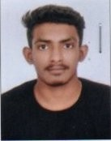 | B pos | VAVILALA KONDA GURUVAIAH  NO.6-7-2, VAVILALA PURAM,BHOLAKPURA, SECUNDERABAD, TELANGANA  - | Male | GM | Indian 2 | Management Seats | 0, 0%  0, 0%  0, 0% | PUC | PCB | 1962218142 | 18/04/2019 | TELANGANA STATE BOAD OF INTERMEDIATE EDUCATION | 600 | 463 | 13/08/2002 | 16/02/2021
28. | SURYA PRATAP | 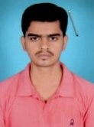 | A neg | BINDESHWAR MANDAL  BONI BANK, JHAGHA JAMUUI - 811308, BIHAR  - | Male | GM | Indian 5 | Management Seats | 422963,  690574000%  0, 0%  0, 0% | PUC | PCB | 820500028-18 | 24/03/2020 | BIHAR SCHOOL EXAMINATION BOARD, PATNA | 300 | 166 | 05/12/2002 | 16/02/2021

29. | SRINIDHI. V | 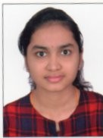 | A pos | VASUDEV  BRUNDHAVANA APARATMENT, MAHALAKSHMI LAY OUT,  BANGALORE- 22  - | Female | GM | Indian 5 | Management Seats | 342310,  749123000%  0, 0%  0, 0% | puc | PCB | 517642 | 16/04/2019 | department of pre university  education | 300 | 209 | 15/11/2001 | 16/02/2021
30. | PRABHAT KUMAR | 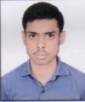 | A pos | RAVINDRA KUMAR  BIRAHIMA VILLAGE, PUCHARA POST AND ps, GURUA DISTRICT, GAYA, BIHAR  - | Male | GM | Indian 5 | Management Seats | 248656,  817932000%  0, 0%  0, 0% | puc | PCB | 19010060 | 30/03/2019 | BIHAR SCHOOL EXAMINATION BOARD, PATNA | 300 | 218 | 29/06/2002 | 16/02/2021
31. | ANSARI  UBAIDULLAH ISRAIL |  | A pos | ISRAIL  SR.No. 7016, NAU BHARAT NAGAR, SUNIL JADMAU, CHAWLDA (POST), PUNE, MAHARASTRA  - | Male | GM | Indian 27 | Management Seats | 356096,  760343000%  0, 0%  0, 0% | PUC | PCB | P009250 | 28/02/2019 | MAHARASTRA STATE BOARD OF HIGHE  RSECONDARY EDUCA | 300 | 159 | 03/02/2001 | 16/02/2021
32. | ROSHANI  MOHD AMIN SHAIKH |  | A pos | MOHD AMIN SHAIKH  D-11, SHUBHANKAR NAGAR, VIKAS NAGAR, DEHU ROAD, PUNE, MAHARASTRA  - | Female | GM | Indian 20 | Management Seats | 255,  403782%  0, 0%  0, 0% | PUC | PCB | 4674874 | 02/05/2019 | CENTRAL BOARD OF  SECONDARY EDUCATION | 300 | 217 | 04/04/2002 | 16/02/2021
33. | VARSHSA.R | 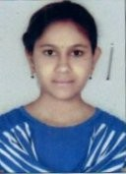 | B pos | RAJAPPA.D  12TH CROSS, WEAVERS  COLONY, KOLIFORM GATE,  BANNERGATTA, BANGALORE  - | Female | GM | Indian 17  Urban | Management Seats | 97,  343493000%  0, 0%  0, 0% | puc | PCB | 200822 | 17/07/2020 | department of pre university  education, karnatak | 300 | 227 | 01/09/2002 | 16/02/2021
34 | MACHKAR ROHAN  RAJENDRA |  | B neg | RAJENDRA  8-503, VRUNDAVAN COMPLEX, GANESH NAGAR, DOMBIVILI WEST MAHARASTRA  - | Male | GM | Indian 21 | Management Seats | 467924,  6575590%  0, 0%  0, 0% | PUC | PCB | M015047 | 28/02/2020 | HIGHER SECONDARY EDUCATION , PUNE | 300 | 221 | 07/07/2001 | 16/02/2021
35 | BANSHANSHEMLANG MARBANIANG | 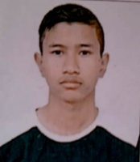 | A pos | PRIMBOR SOHTUN | Male | GM | Indian | Management Seats |  | PUC | PCB |  |  |  |  |  | 03/03/2002 | 16/02/2021
36 | LAPYNHUNSHISHA KHONGWIR | 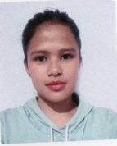 | A pos | F. KHARBUI | Female | GM | Indian | Management Seats |  | PUC | PCB |  |  |  |  |  | 07/08/2000 | 16/02/2021
37 | UMME SALMA KHATUN | 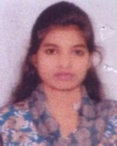 | A pos | Moksed ali | Female | GM | Indian | Management Seats |  | PUC | PCB |  |  |  |  |  | 01/01/2001 | 16/02/2021

38 | MARINAS AHMED | 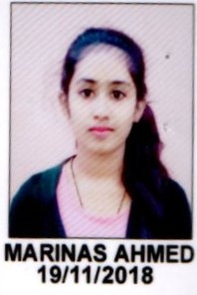 | B pos | MOHIRUDDIN AHMED  Kabaitary PT- IV Dist- Bongaigoon  Assam – 783 388 | Female | GM | Indian | Management Seats |  | PUC | PCB |  |  |  |  |  | 11/10/1999 | 16/02/2021
39 | ROHAN BHADRA |  | B neg | R.K. BHADRA  285, de loGANTHAN STREET, PONNAPPA NADAR COLONY, NAGARCOIL  TAMIL NADU | Male | GM | Indian | Management Seats |  | PUC | PCB |  |  |  |  |  | 24/11/2000 | 16/02/2021
40 | KHAN MOHAMMAD WASEED MOHAMMAD ILYAS |  | A pos | MOHAMMAD ILYAS  R.No. 101, RAMNARESH SINGH, | Male | GM | Indian | Management Seats |  | PUC | PCB |  |  |  |  |  | 12/11/1998 | 16/02/2021
41 | PARIMALA.S | 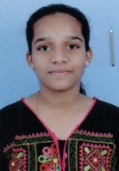 | A pos | SRINIVAS. B  NO. 146, 2nd A Main Road, 8th Cross, Near Muneshwara Temple, Bhairaveswara Nagar, Laggere, Peenya Smalla Industries,  Bangalore – 560 058 | Female | GM | Indian | Management Seats |  | PUC | PCB |  |  |  |  |  | 23/01/2003 | 16/02/2021
42 | SHIVANI CHANDRAKAN TAYDE | 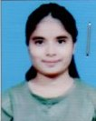 | A pos | CHANDRAKANTH  Sharadrahiwashisang, near boyant cineme chamber,  mumbai | Female | GM | Indian | Management Seats |  | PUC | PCB |  |  |  |  |  | 10/11/2000 | 16/02/2021
43 | MEGHANA.K.M | 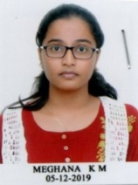 | B pos | K.N. MOHAN  No. 112, FORT STREET, ARKALGUD (T), HASSAN(D), KARNATAKA – 573 130 | Female | GM | Indian | Management Seats |  | PUC | PCB |  |  |  |  |  | 31/01/2002 | 16/02/2021
44 | DWIVEDI ABHISHEK RAMJI | 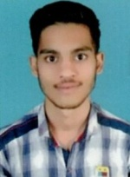 | B neg | RAMJI  NAVADURGARAHI VAJISEAMAN, DAL BHIMNAGAG KURAR VILLAGE, MALADEUS, MUMBAI - 97  MAHARASTRA | Male | GM | Indian | Management Seats |  | PUC | PCB |  |  |  |  |  | 23/01/2001 | 16/02/2021
45 | ISHAAN ATUL CHOUDHARY | 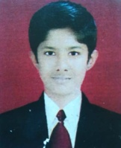 | B neg | ATUL CHAUDHARY  Near by Balaji Mandir, Gadipura Nanded – 451604  MAHARASTRA | Male | GM | Indian | Management Seats |  | PUC | PCB |  |  |  |  |  | 13/01/2003 | 16/02/2021

46 | SUBHADEEP SAHA | 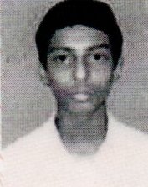 | A pos | RATAN KR SAHA | Male | GM | Indian | Management Seats |  | PUC | PCB |  |  |  |  |  | 12/01/2001 | 16/02/2021
47 | SHARANYA.H | 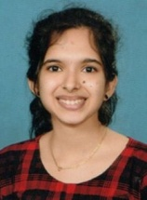 | A pos | SHIVARAMAYYA.H  1/142, KARMAJI, KUTHUKENJA SULLIA TALUK, KUTHKUNJA, DAKSHINA KANNADA, KARNATAKA  PIN – 574 232 | Female | GM | Indian | Management Seats |  | PUC | PCB |  |  |  |  |  | 02/06/2002 | 16/02/2021
48 | YADAV VANDANA VINOD |  | A pos |  | Female | GM | Indian | Management Seats |  | PUC | PCB |  |  |  |  |  |  | 16/02/2021
19 | MHATRE DISHA MANOJ |  | B pos |  | Female | GM | Indian | Management Seats |  | PUC | PCB |  |  |  |  |  |  | 16/02/2021
50 | MOHAMMED RASOOL |  | B neg |  | Male | GM | Indian | Management Seats |  | PUC | PCB |  |  |  |  |  |  | 16/02/2021

